|  |
| --- |
| **This assignment should take an average student who is up-to-date with tutorial work approximately 25 hours**  **Deadline: your work must be submitted before the last week of this semester.** |

|  |
| --- |
| **Plagiarism** is presenting somebody else’s work as your own. It includes: copying information directly from the Web or books without referencing the material; submitting joint assignment as an individual effort; copying another student’s assignment; stealing or buying assignment from someone else and submitting it as your own work.  Suspected plagiarism will be investigated and if found to have occurred will be dealt with according to the procedures set down by the University.   **All material copied or amended from any source (e.g. internet, books) must be referenced correctly according to the reference style you are using.** |

**1>Detailed Specification**

This is an individual assignment.

You are asked to provide a web application for Attendance Taking & Student Grade Management System at FPT University (I know, FPT already got one, but let assume we are reconstructing it).

You can base on existing sources to develop your design including: fap.fpt.edu.vn, flm.fpt.edu.vn, ...

**Attendance Taking Sub-System**

Every semester, Lecturers and students will receive their schedules for classes. The below figure displays an example of the particular lecture, you can check your own to see the detail schedule for student.

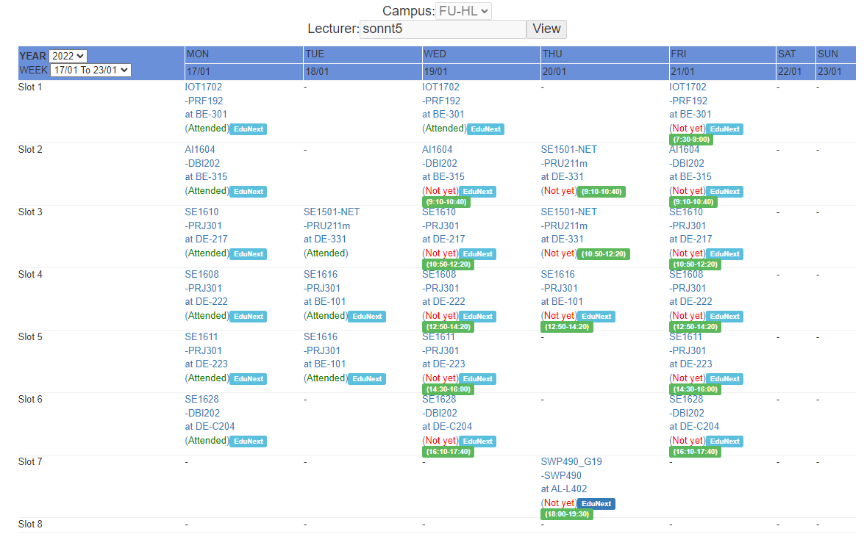

Each class, the lecture going to take attendance for student, all of their absent/present will be recorded.

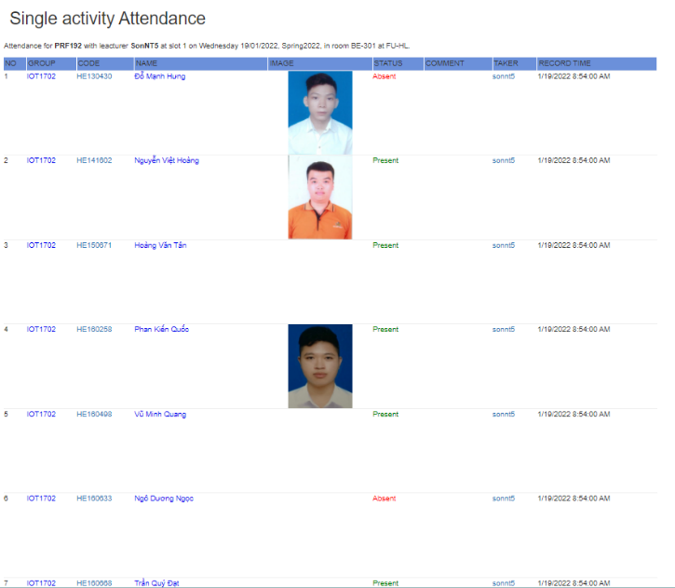

The list of students is grouped by the training department (no need to worry how they can create the list; it is a different story to concern).

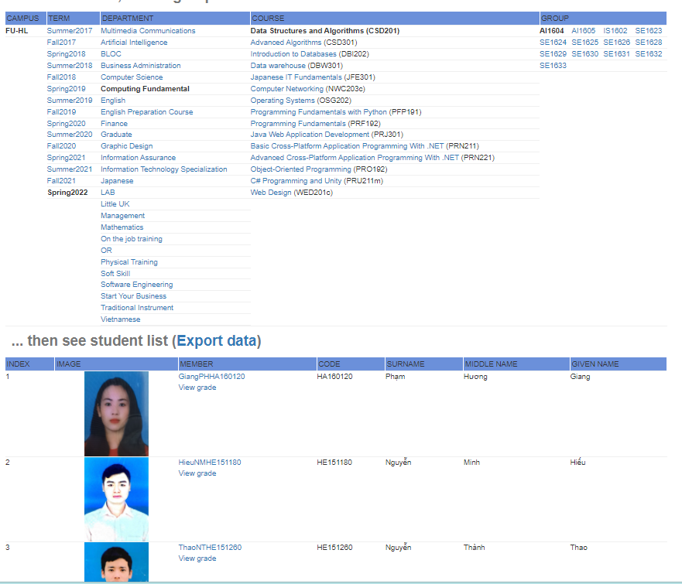

Hint: check the instructions you got before

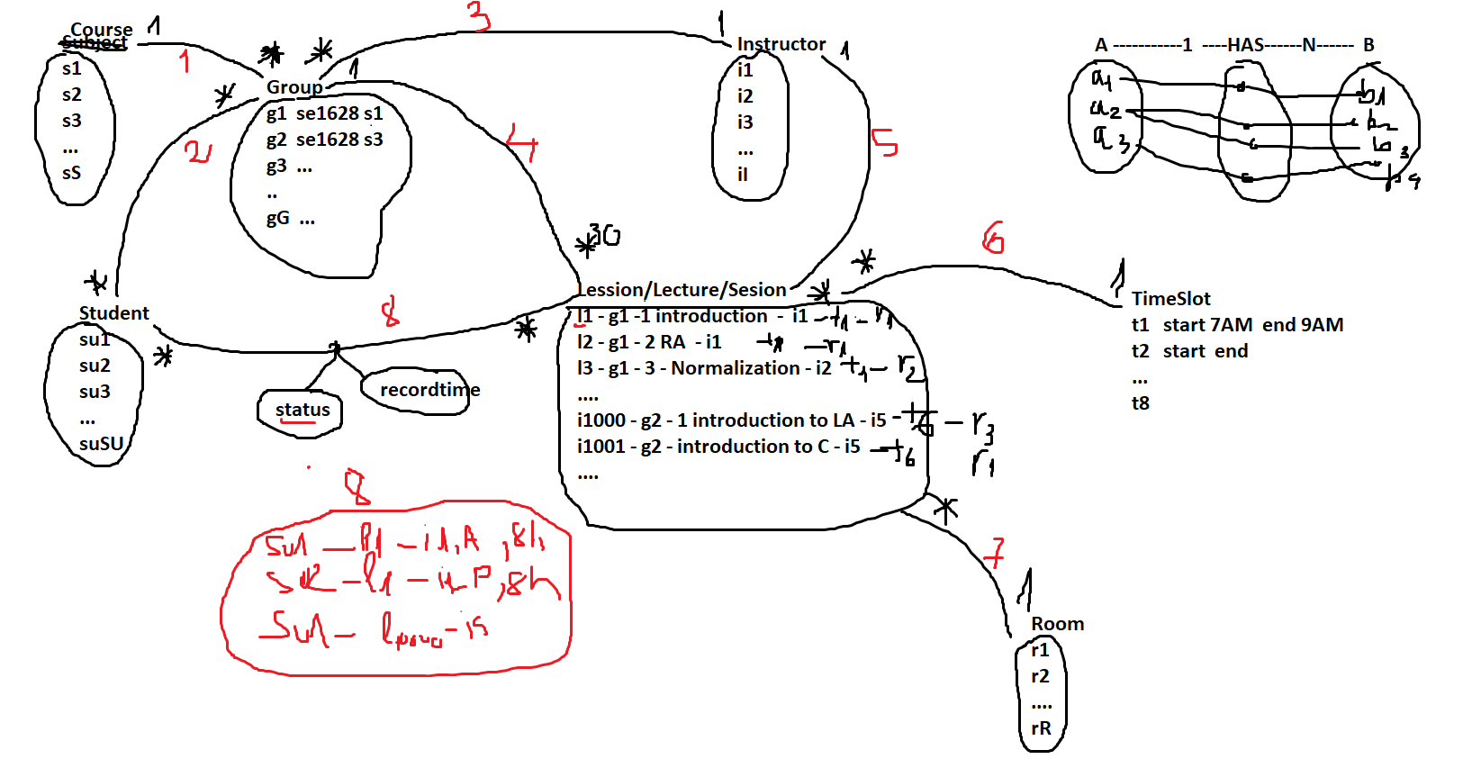

**Student Grading Management Sub-System**

For each subject that attended by the student, the lecture will give score to the assessment to each of their assessment. Below figure shows an Example of the assessments for course DBI202.

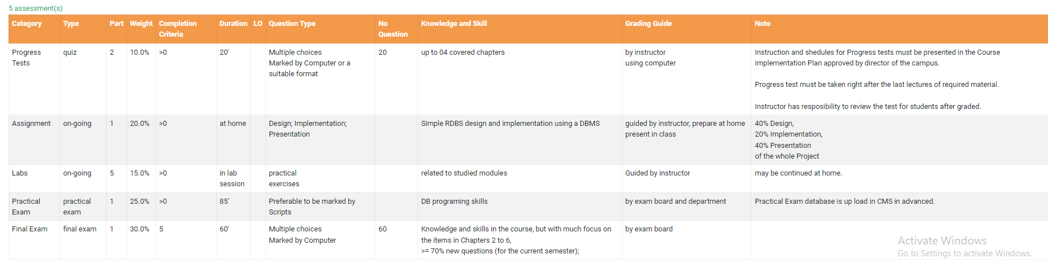

Students can check their results at the end of semester as following example:

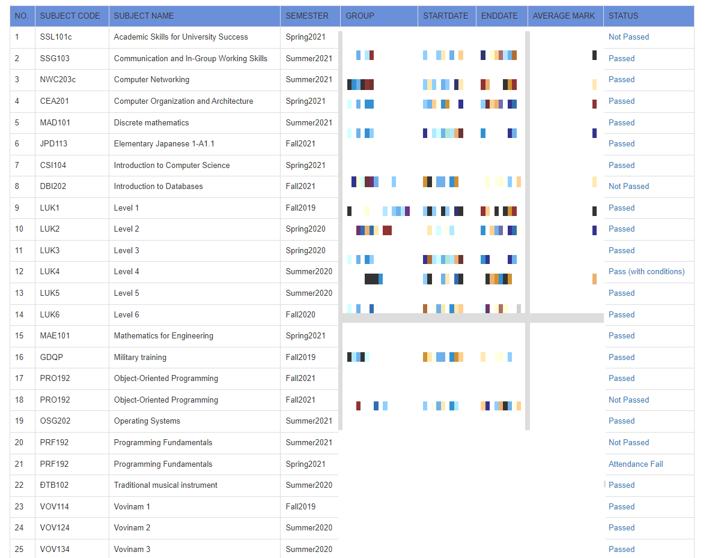

Each Subject code, student can check their detailed result of as below example:

